--6. Show the name of the guest, occupant, date of check in and check out and number of nights for booking 5046

SELECT \* FROM vBookingDetails5046

Table 'guest'. Scan count 0, logical reads 2

Table 'booking'. Scan count 0, logical reads 2,

CPU time = 0 ms, elapsed time = 64 ms.

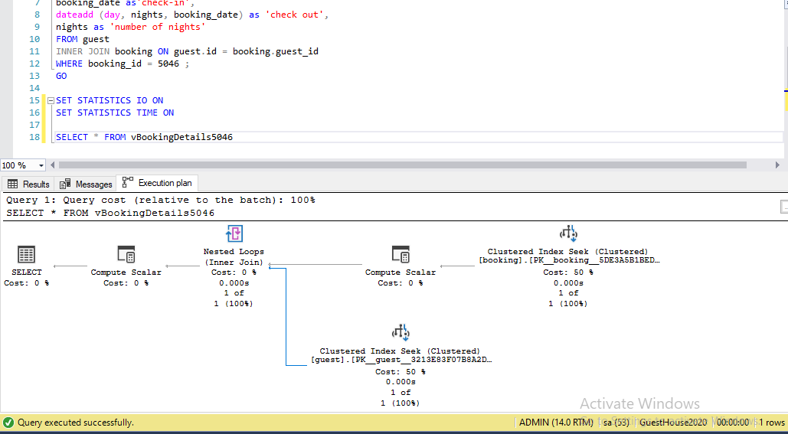

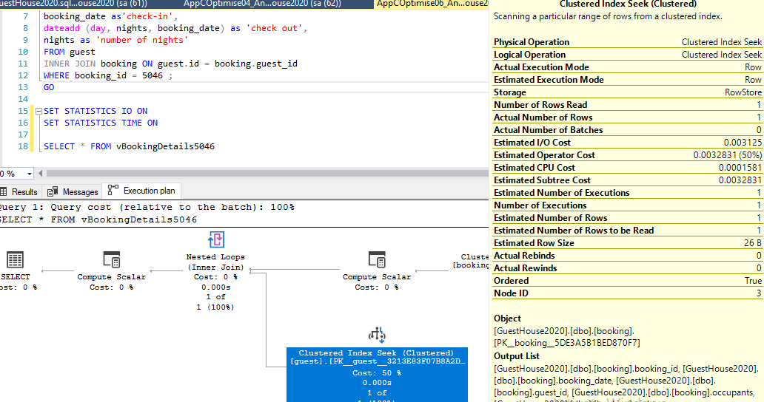

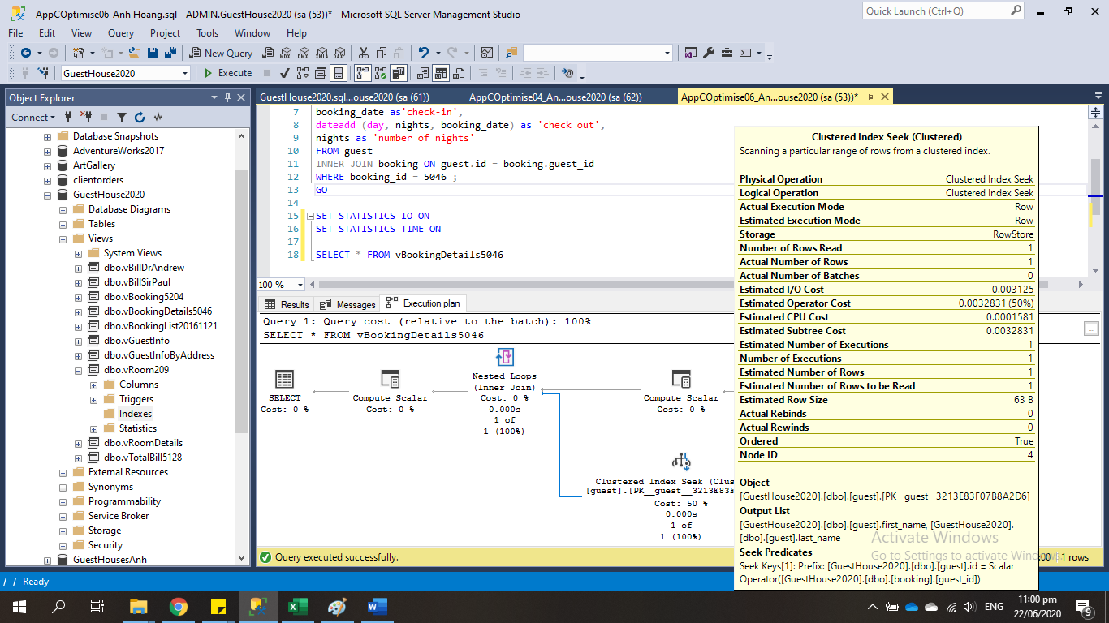

CONCLUSION

Looking at the execution plan, we can see SQL scan data by using Clustered Index Seek – this is a very efficient way to find single rows or small ranges. We also see that the number of rows read equal to actual number of rows (1) . It is obvious that this is a good query .